Introduction to Statistics and Data Analysis - YouTube

🧠 Lecture Summary: Introduction to Statistics (Steve Brunton, UW)

🎯 Overview
- This is the second half of the Probability & Statistics course.
- Probability deals with modeling uncertainty (model → data).
- Statistics deals with inference from data (data → model).
- Core of data science and machine learning — using data to infer models, make predictions, and test hypotheses.

⚖️ Probability vs. Statistics
Concept | Probability | Statistics
Known | Model / Distribution | Data / Samples
Unknown | Data | Model / Parameters
Goal | Predict likely outcomes | Infer parameters, test hypotheses
Example | “Given a fair die, what’s the chance of rolling 6?” | “Given rolls, is the die fair?”

🧩 Key Topics Covered

1. Survey Sampling
- Draw a small sample from a large population.
- Compute sample mean (x̄) to estimate population mean (μ).
- Central Limit Theorem (CLT):
  - The distribution of sample means → Normal as n → ∞.
  - Mean = μ, Variance = σ²/n.
- Tells how sample size affects accuracy and confidence.
🧮 Formula:


2. Hypothesis Testing
- Framework to decide if an effect is statistically significant.
- Compare control vs treatment, e.g.:
  - Does a drug work?
  - Did a marketing campaign increase clicks? (A/B testing)
- Uses distributions like Normal and Chi-Square (χ²).
🧠 Examples of Tests:
- t-test (compare two means)
- χ² test (compare distributions)
- z-test (known variance)
🔢 Outputs:
- p-value → probability of observing results by chance.
  - p < 0.05 ⇒ statistically significant.
- Confidence level (e.g. 95%, 99%).
⚠️ Beware of p-hacking (bad or manipulative experimental design).

3. Experimental Design
- Plan data collection and testing carefully.
- Goals:
  - Ensure validity (fair test)
  - Ensure significance
  - Avoid bias and false positives
- Example: Randomized controlled trials for drug testing.

4. Fitting Distributions & Parameter Estimation
- Given data, estimate the parameters (θ) of its probability model.
Concept | Meaning
Probability | P(x | θ)
Statistics | P(θ | x)
x : data
θ : parameter
🧠 Techniques:
- Method of Moments: Estimate parameters using sample moments.
- Maximum Likelihood Estimation (MLE):
Find θ that maximizes P(x | θ).
- Goodness of Fit: Evaluate how well model matches data.
- Confidence Intervals: Quantify uncertainty in parameter estimates.
🧮 Example:
Estimate μ, σ in Normal(μ, σ²) using data → report (μ̂ ± CI).

5. Bootstrapping & Monte Carlo Simulation
- Use resampling or simulation to estimate uncertainty.
- Useful when analytic solutions are hard.
- Core of Bayesian inference and computational statistics.

6. Bayesian Statistics
- Combine prior beliefs + new data to update knowledge.

- Allows incorporating prior knowledge (priors).
- Prevents overreacting to small data samples.
- Core of Bayesian Machine Learning.
📘 Example: Coin flipping
If you get 3 heads in a row, Bayesian stats consider prior belief (likely fair) before concluding it’s biased.

7. Advanced & Modern Topics
- Benford’s Law
- Markov Chains
- Random Walks
- Gaussian Processes
- Stochastic Differential Equations
- Monte Carlo Optimization
- Bayesian Machine Learning
These extend classical statistics into computational and probabilistic modeling of complex real-world systems.

🧾 Quick Cheatsheet for Exams

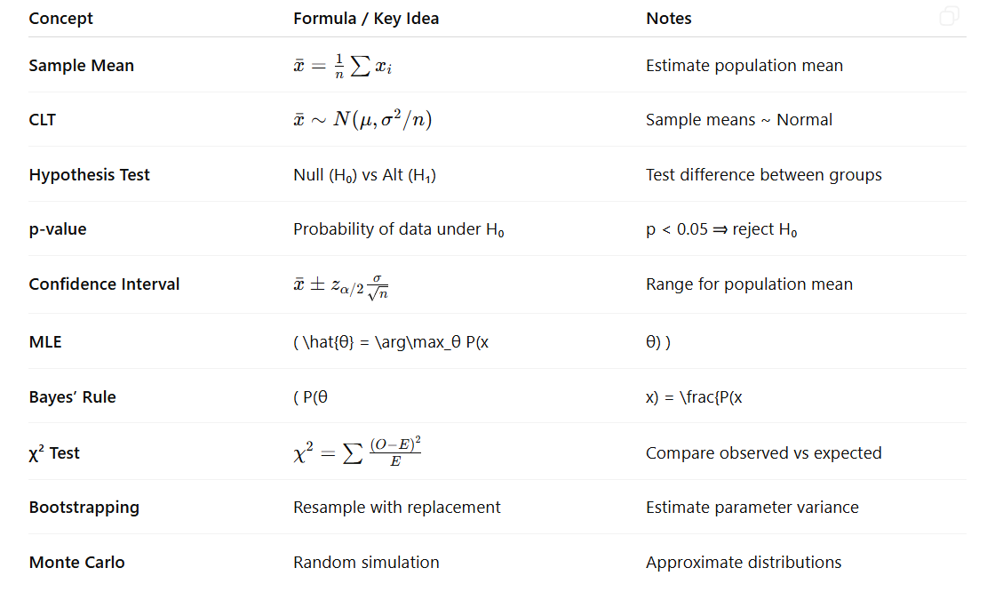

📘 Statistics (Part 2 of Probability & Statistics) — Summary + Exam Cheatsheet

🧠 Overview
- Probability → model → data
(We know the model, predict data.)
- Statistics → data → model
(We know the data, infer the model.)
Statistics is the foundation of data science and machine learning, helping us estimate, test, and predict from real data.

⚖️ Probability vs. Statistics
Concept | Probability | Statistics
Known | Model, Distribution | Data, Samples
Unknown | Data | Model Parameters
Goal | Predict outcomes | Infer or test parameters
Example | Given a fair die, chance of 6? | Given rolls, is the die fair?

🔹 Core Topics

1️⃣ Survey Sampling
- Draw a sample from a population → compute sample mean (x̄).
- Central Limit Theorem (CLT):
  - As sample size ↑, sample mean approaches population mean.
  - Variance decreases with larger samples → more confidence.

2️⃣ Hypothesis Testing
Used to decide if differences or effects are statistically real.
Examples:
- Does a drug work (control vs. treatment)?
- Did a marketing change increase clicks (A/B test)?
- Are two distributions the same (χ² test)?
Key outputs:
- p-value: Probability results occur by chance.
  - p < 0.05 ⇒ reject H₀ (statistically significant).
- Confidence Level: 95%, 99%, etc.
⚠️ Watch out for p-hacking → manipulating design or data to fake “significance.”

3️⃣ Experimental Design
Design fair, valid experiments:
- Define control and treatment groups.
- Randomize, replicate, and ensure unbiased measurement.
- Use proper sample sizes and report confidence levels.

4️⃣ Fitting Distributions & Parameter Estimation
Estimate unknown parameters (θ) from data.
Concept | Explanation
Probability: P(x | θ) — data from model
Statistics: P(θ | x) — model from data
Methods:
- Method of Moments: Use sample moments (mean, variance).
- Maximum Likelihood Estimation (MLE):

- Goodness of Fit: Test how well model matches data.
- Confidence Interval: Range for true parameter value.

5️⃣ Bootstrapping & Monte Carlo Simulation
- Bootstrapping: Randomly resample data (with replacement) to estimate variability.
- Monte Carlo: Simulate thousands of samples to approximate uncertainty.
- Great for complex or unknown distributions.

6️⃣ Bayesian Statistics
Combines prior beliefs and new data to update understanding.
Bayes’ Rule:
- Incorporates prior knowledge (“the coin is probably fair”).
- Produces posterior belief after seeing data.
- Core of Bayesian machine learning and uncertainty modeling.
🪙 Example: After 3 heads, don’t instantly assume the coin is biased — priors matter.

7️⃣ Advanced Topics
- Benford’s Law
- Markov Chains
- Random Walks
- Gaussian Processes
- Stochastic Differential Equations
- Monte Carlo Optimization
- Bayesian Machine Learning
These extend classical statistics into computational and data-driven modeling.

🧾 Exam Cheatsheet (Formulas & Keywords)

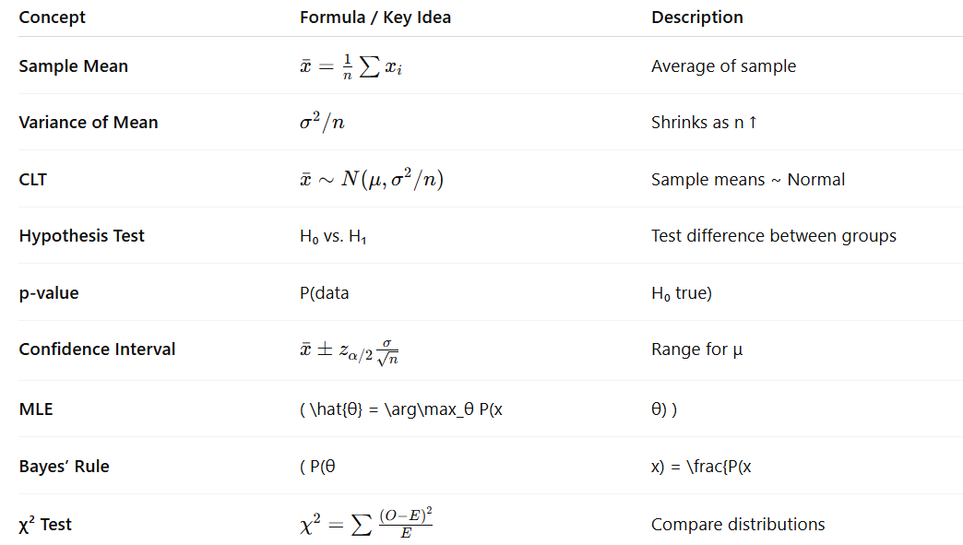

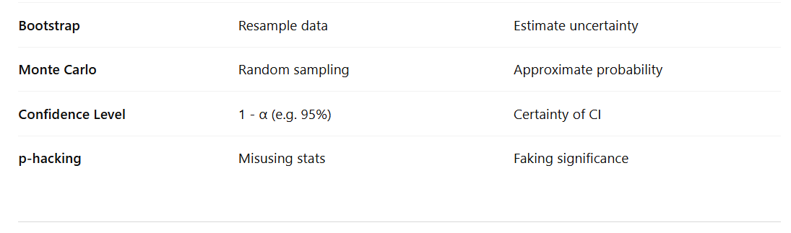
✅ Key Takeaway:
Statistics is the bridge from data to understanding.
It lets us estimate, test, and predict, turning uncertainty into actionable knowledge.

